3: plotting graphs using R tool

Histogram:

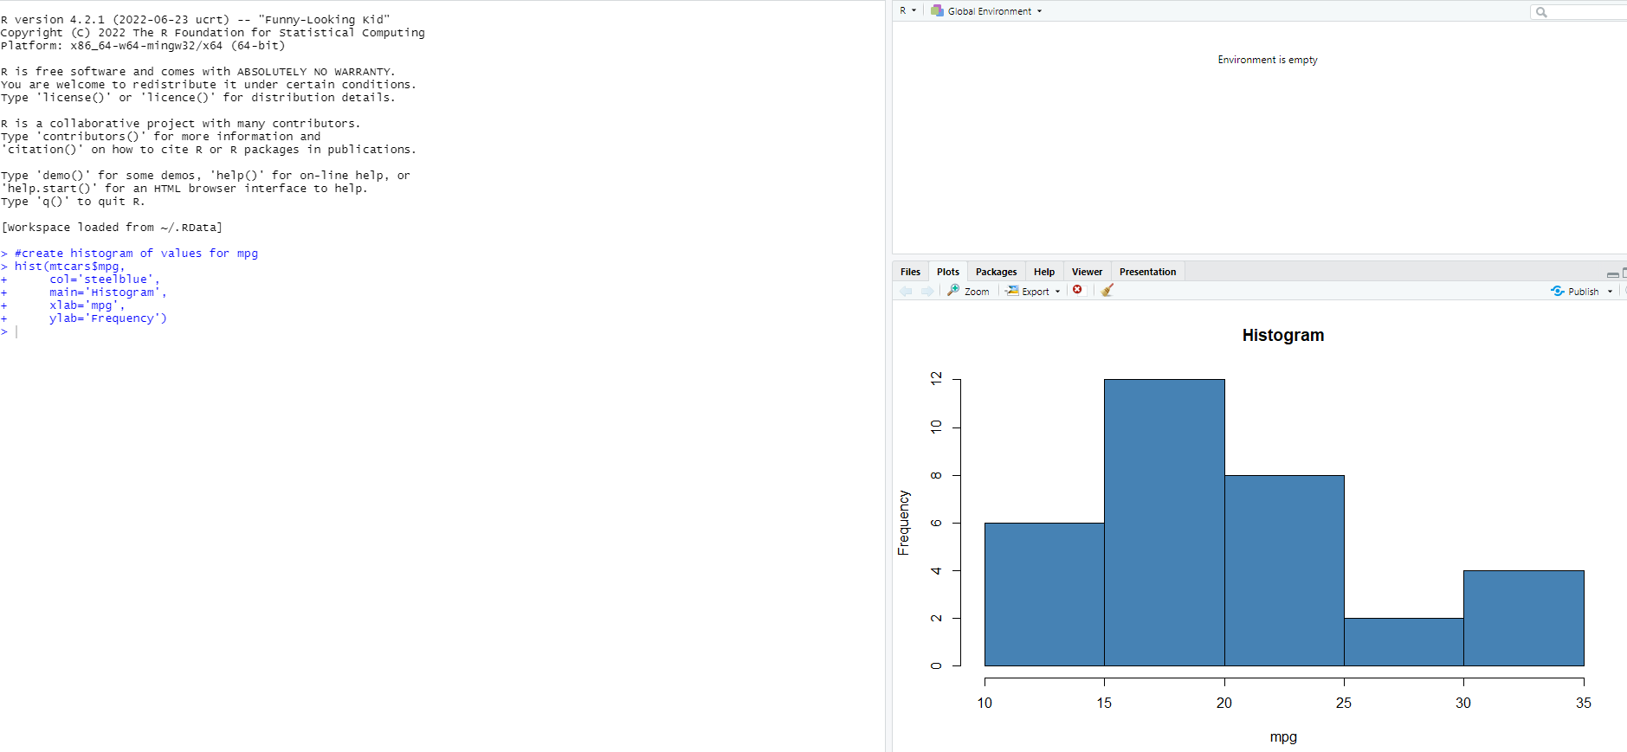

Distribution of mpg values:

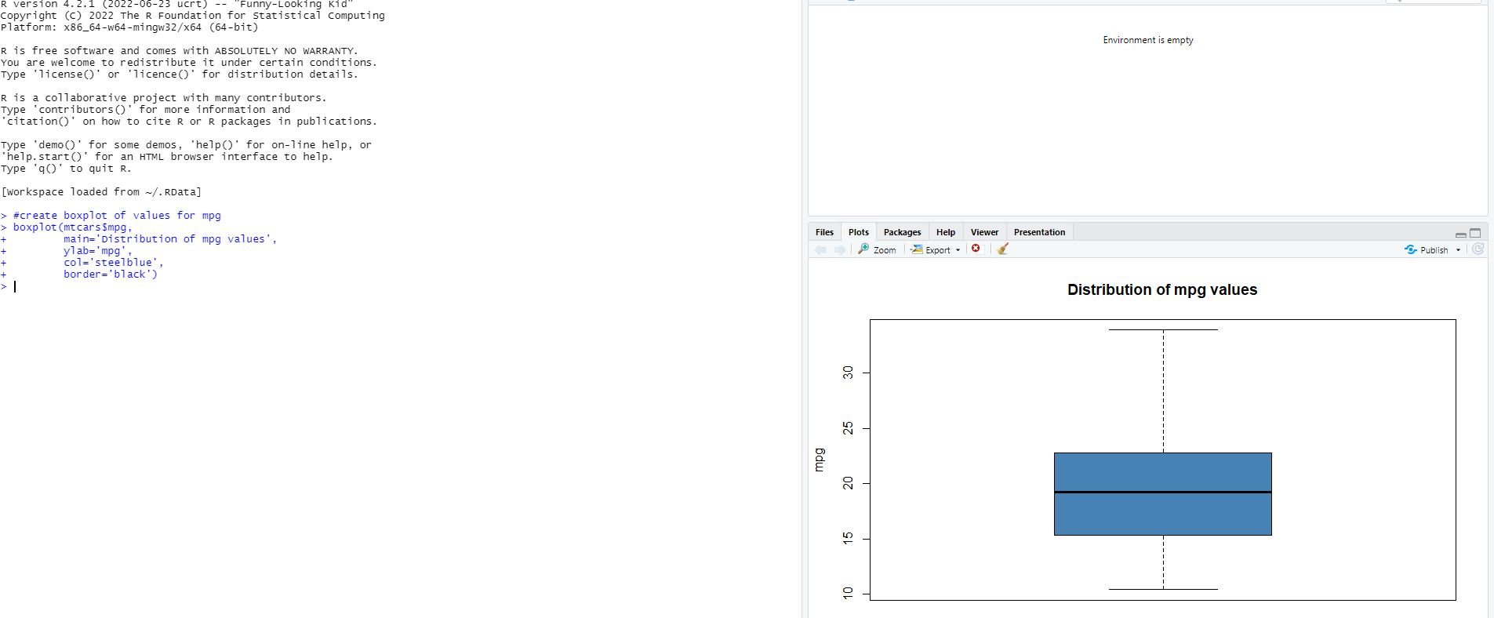

Scatterplot:

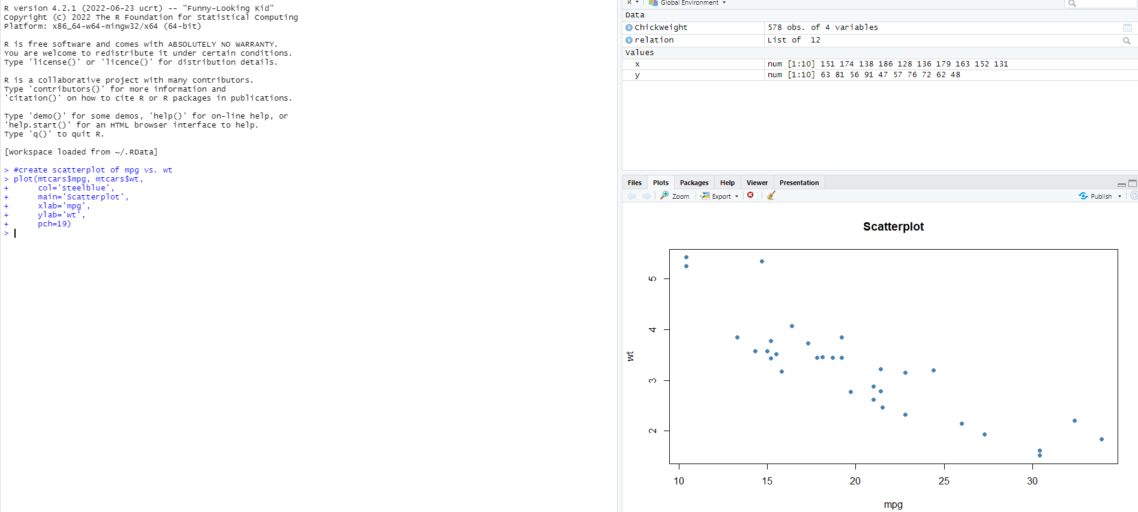

2: Linear regression through R tool